Gift Aid 100mm black

***There are many benefits of becoming a Friend of St Michael’s Church, Shotwick***

***✞ Most importantly your generosity will help to***

***keep the church building open and accessible for***

***future generations***

***✞ Continued open daily access for visitors as well as***

***the availability of the church for quiet reflection,***

***weddings and funerals***

***✞ As a ‘Friend’ you will receive regular newsletters***

***to keep you informed about the church building,***

***its maintenance and upkeep as well as future***

***fund-raising activities***

***✞ Invitations to events organised by the ‘Friends of***

***St Michael’s Church’ including historic talks and***

***visits to other places of interest***

***✞ Invitation to attend the Annual Parochial Church***

***Meeting to discuss your ongoing support for this***

***historic building and churchyard***

The Benefits of Becoming a

**‘Friend of St Michael’s Church’**

***If you are a UK tax payer please consider Gift Aiding your donations.***

**Friends of**

**St Michael’s Church**

***Shotwick***

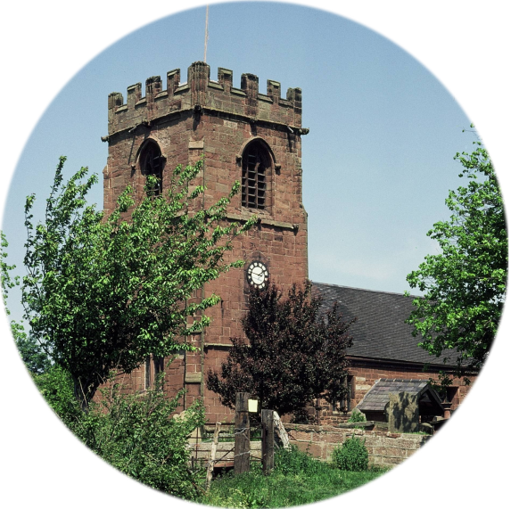

*Please treat as Gift Aid donations all qualifying gifts of money made from the date of this declaration and in the past four years. I confirm I have paid or will pay an amount of Income Tax and/or Capital Gains Tax for each tax year (6 April to 5 April) that is at least equal to the amount of tax that all the charities (including churches) and Community Amateur Sports Clubs that I donate to will reclaim on my gifts for that tax year. I understand that other taxes such as VAT and Council Tax do not qualify. I understand the charity will reclaim 25p of tax on every £1 that I give.*

*I want to Gift Aid my donation of £______________ and any donations I make in the future or have made in the past 4 years to St. Michael’s Church*

*:*

*Signature........................*

*Date ……/……/......*

**Preserving the Church Now & for Future Generations**

*St. Michael's at Shotwick is one of Cheshire's hidden treasures. It dates from the time of the Domesday survey in 1086. Although the church was rebuilt in the 14th century the original Norman arch to the entrance remains. The tower dates from 1500. The box pews, churchwardens' pew and the three tiered pulpit are special features of the church furniture. There are six bells in the tower two dated 1616 and 1621 with four added in 1938. The earliest surviving registers date from 1698 and the list of incumbents goes back to 1333. Visit our website at* ***www.shotwick.org.uk***

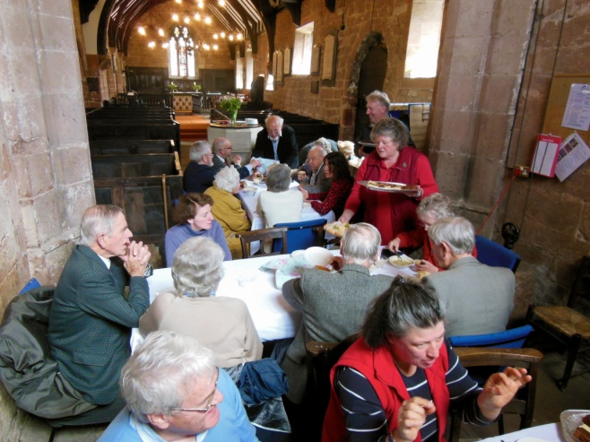

***For tax payers this will add 25% to the value of your donations***

Gift Aid 100mm black



*The Friends of St. Michael's Church started in 1998.  Then, as now, the aim was to keep the church open and to maintain the fabric, guarding against damp, rot and the general signs of decay inevitable in the ancient building.  Then, as now, there were many who loved the church, some had old family links - baptism, marriage and graves in our peaceful country churchyard - and they would not wish the church to close.  Thus, the Friends began and that was when the Newsletters were*

*started as an acknowledgement of the help given and to keep Friends informed.  At that time an annual donation of £5 was set but Friends were and are generous.*

*Now it is up to us to carry on.  The Diocesan Architect inspects the building every 5 years and issues a report.  Our Building Committee and the PCC decide on priorities and so it goes on.*

*The contributions of the Friends are greatly appreciated in these times of rising costs and almost non-existent interest.*

*This, then, is an appeal to you to become, or to renew your membership and thus help to keep St. Michael's Church open.  We hope you enjoy receiving the Newsletters and the information on all our activities.*

***This cannot happen without your help and generosity****.*

**Please complete this section and send it to The Friends Administrator, The Vicarage, Vicarage Lane, Burton, Neston, CH64 5TJ**

*I wish to become a member of ‘The Friends of St Michael’s Church’. I would like to help maintain this historic building and preserve it for future generations.*

***Name ....................................................***

***Address: .....................................................***

***.....................................................***

***.....................................................***

***Postcode: .....................................................***

***Email: .....................................................***

**Bank Standing Order Instruction**

**Please complete this section and return it with your application.**

**To** (*Name of Bank*) **.............................................**

**Bank Address .............................................**

**............................................ Postcode.......................**

**Account Name ...........................................................**

**Sort Code .........................Account No........................**

**Pay £ _________ per month until further notice**

**with the first payment on (date) ................................**

**Pay to: Nat West Bank, Queensferry Branch**

**a/c St Michael’s Church, Shotwick**

**Sort Code Account Ref:**

**54 30–23 01406426 Friends**

**Signed _________________________ Date ____________**

***OR***

*I enclose a cheque*

*Payable to St Michael’s Church Shotwick*

*Many people, either living in the parish or beyond, have a strong connection with St Michael’s Church. Such people often have fond memories of services attended – weddings, funerals, or school events. Others, as visitors, have been enchanted by the quiet simplicity of the building, its history and its surroundings. It is a church for everyone, but the costs associated with its maintenance are considerable.*

*It is, therefore, becoming increasingly difficult for parishioners alone to shoulder the responsibility of maintaining the church. Costs include light and heat, building maintenance, the upkeep of the churchyard and repairing the sandstone walls. Simply keeping the church open and accessible for all who wish to see St Michael’s continue to exist as a landmark and focal point on the local landscape is expensive.*

**St Michael’s Church, Shotwick**

**Application for Membership**

**Why Your Support is Vital**



**Friends of St Michael’s Church**

***‘Friends of St Michael’s Church’*** *is a community of people who support St Michael’s PCC in its wish to see the church preserved for the benefit of all who live and work in the parish. All funds raised by* ***‘The Friends’*** *are devoted to the maintenance, repair and upkeep of the fabric of the building and its churchyard.*

*Any donation you are able to make in support of this cause will be very much appreciated. In order to make an impact on the cost of maintaining the church within what is a relatively small parish either a single annual gift of £50 or whatever you would like to give and/or a regular monthly donation of £5 or £10 might be a reasonable guide.*





£

***Contrary to what some might believe, St Michael’s Church is totally self-funded and receives no direct funding from Government or central Church of England resources.***