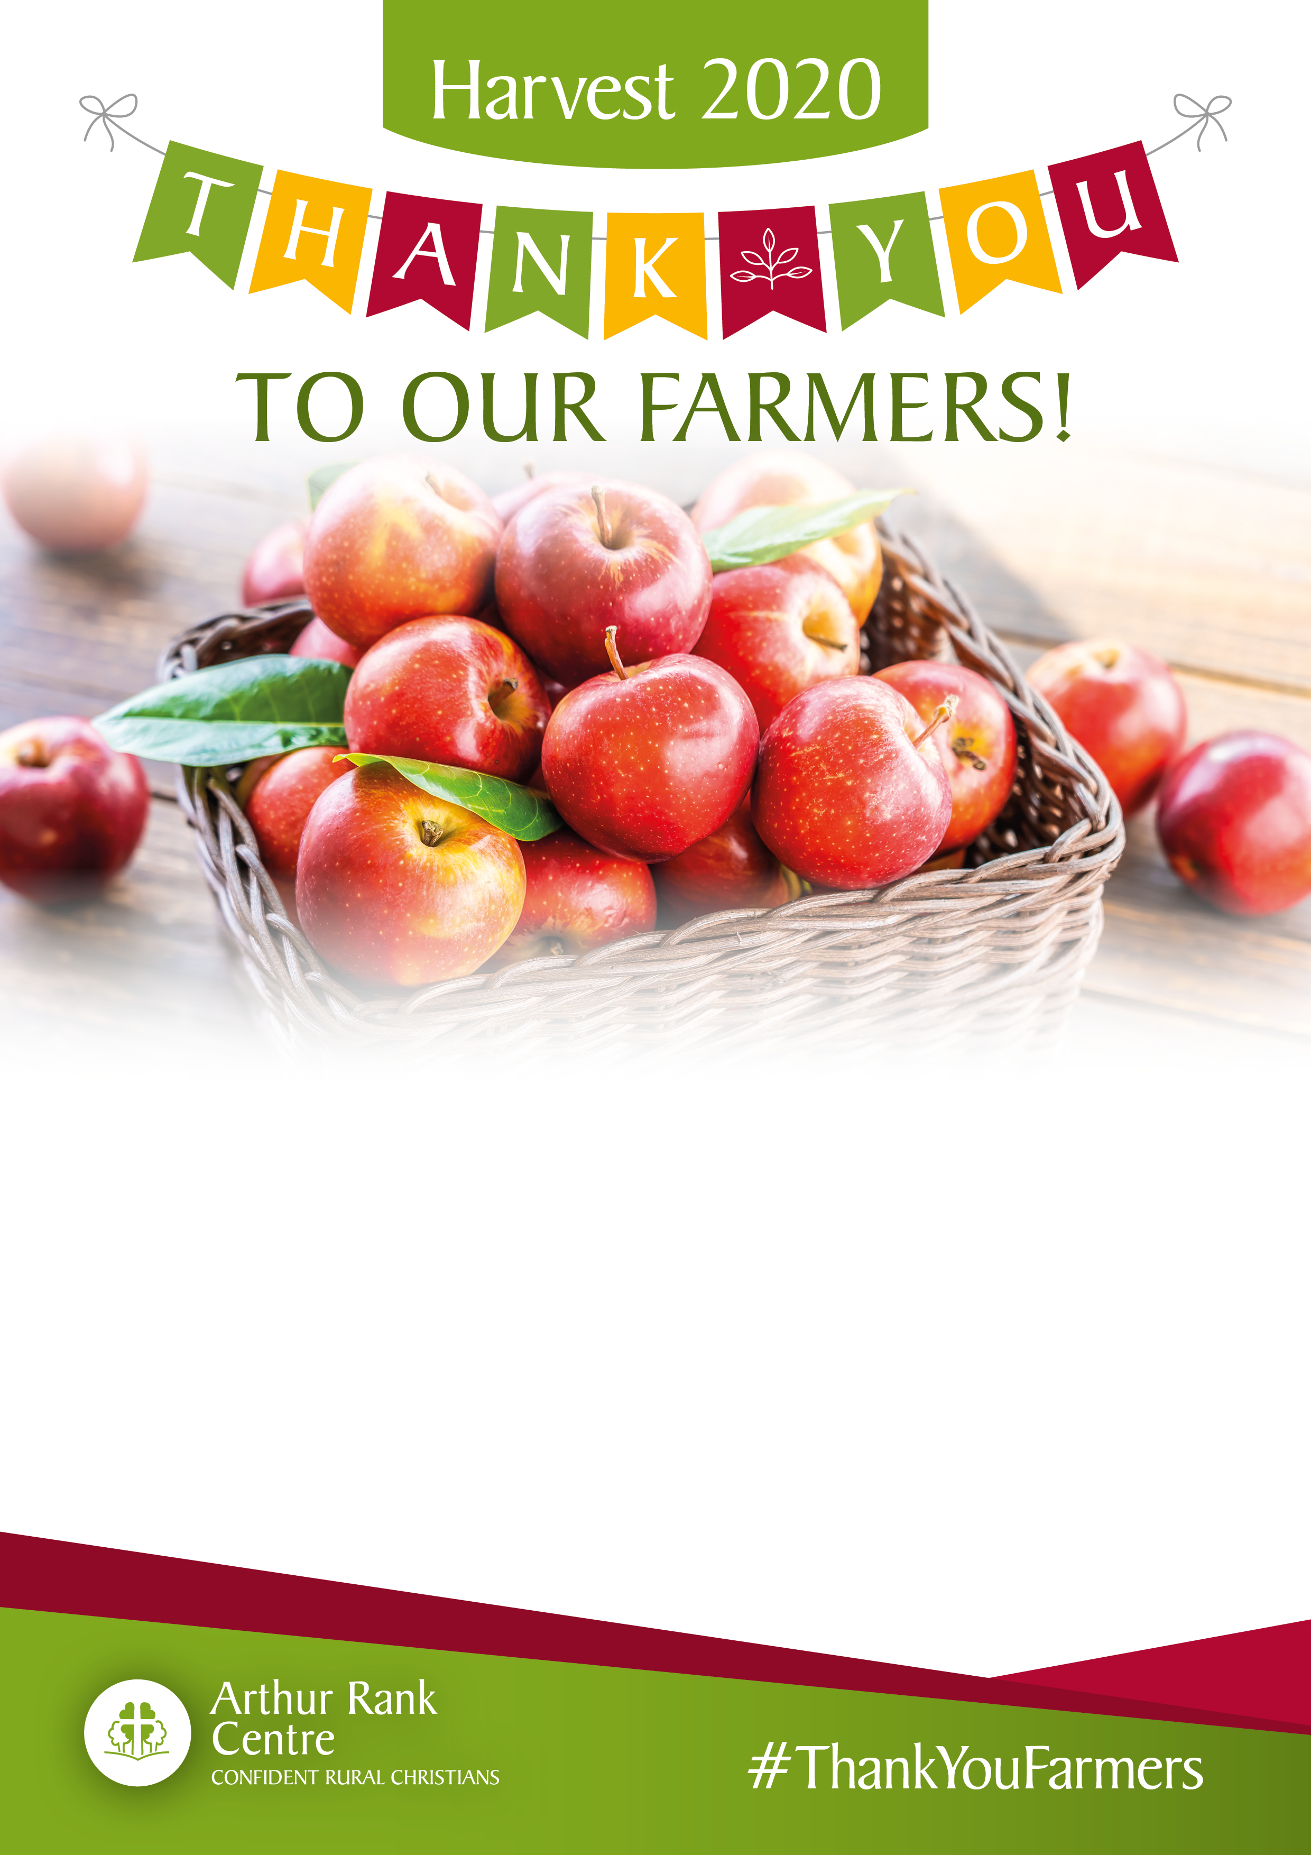

**Harvest Festival outside**  
***bring your own chair and umbrella!***

***Social distancing rules will apply***

**Sunday 11th October at 3pm**

**Please bring donations of tins/packets/toiletries for the Foodbank**